

Vaccination Management System


CVTS
TABLE OF CONTENTS

- INTRODUTION --------------------02

- PROPOSED SCENARIO ------------------02

- SYSTEM MODULE ------------------03

- MODULE DESCRIPTION ------------------04

- THE COMPANY

  - Introduction

In the existing system, Vaccines are provided for infants and children under teenage by various aspects such as by attending school manually and there is a chance that some of the children’s and infants may miss the opportunity of getting vaccinated due to some mandatory reasons. Which leads to loss of life or gets affected by various diseases such as polio… etc? This is a time delay process to wait for each and every one all over the places.

  - PROPOSED SOLUTION
We can change this manual system into e-vaccination system by collecting the info of infants, registered under website so that those who didn’t took vaccination can avail one more opportunity to save the life of their children . By this system a lot of man-hours can be saved and it is efficient too.
  - SYSTEM MODULE

Admin
- All child details
- Date & time of vaccination
- Report of vaccination
  - Child, Vaccination (Date wise report)
- List of vaccine
  - available or unavailable
- Request from parents
  - Approve or Reject
- Add Hospital
  - Update/Delete Hospital
- List of hospitals
- Booking Details



Parent
- Register & Login
- Details of child
- Vaccination Dates
- Book Hospital
- Request for hospital
- Report of vaccination taken
- My profile
.

Hospital
- Register & Login
- Update Vaccine status

  - MODULES DESCRIPTION

Admin
- All child details
  - View all child profile details
- Date of vaccination
  - Upcoming Date of vaccination of all child
- Report of vaccination
  - Child, Vaccination (Date wise report)
- List of vaccine
  - available or unavailable
  - Admin can view the availability of the vaccination
- Request from parents
  - Approve or Reject
  - Once the request for appointment from parent side, it will be approved from the admin
- Add Hospital
  - Admin can add the hospital details
- Update/Delete Hospital
  - Admin can update or delete the hospital details
- List of hospitals
  - Admin can view the hospital details
- Booking Details
  - Admin can view the booking details from parent side for booking vaccination

Parent
- Details of child
  - Update and maintain the child details of vaccination
- Vaccination Dates
  - Can get notified through in Dashboard of their respective accounts about upcoming vaccinations.
- Book Hospital
  - Use can search the list of hospital and book schedule for the vaccine dates
- Report of vaccination taken
  - Can get the report status of previous vaccination of their respective Infants

Hospital
- Register & Login
  - Can register and login into the app with hospital name, address and location details.
- Update Vaccine status
  - Hospital will receive the appointment once its booked from admin side. If vaccination is completed they will update the status to Vaccinated or not.

HOME

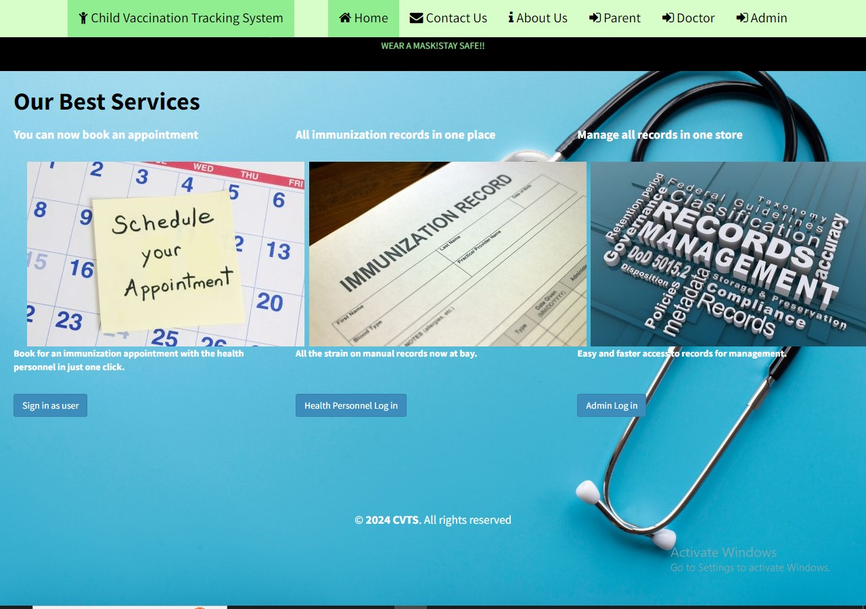

ADMIN

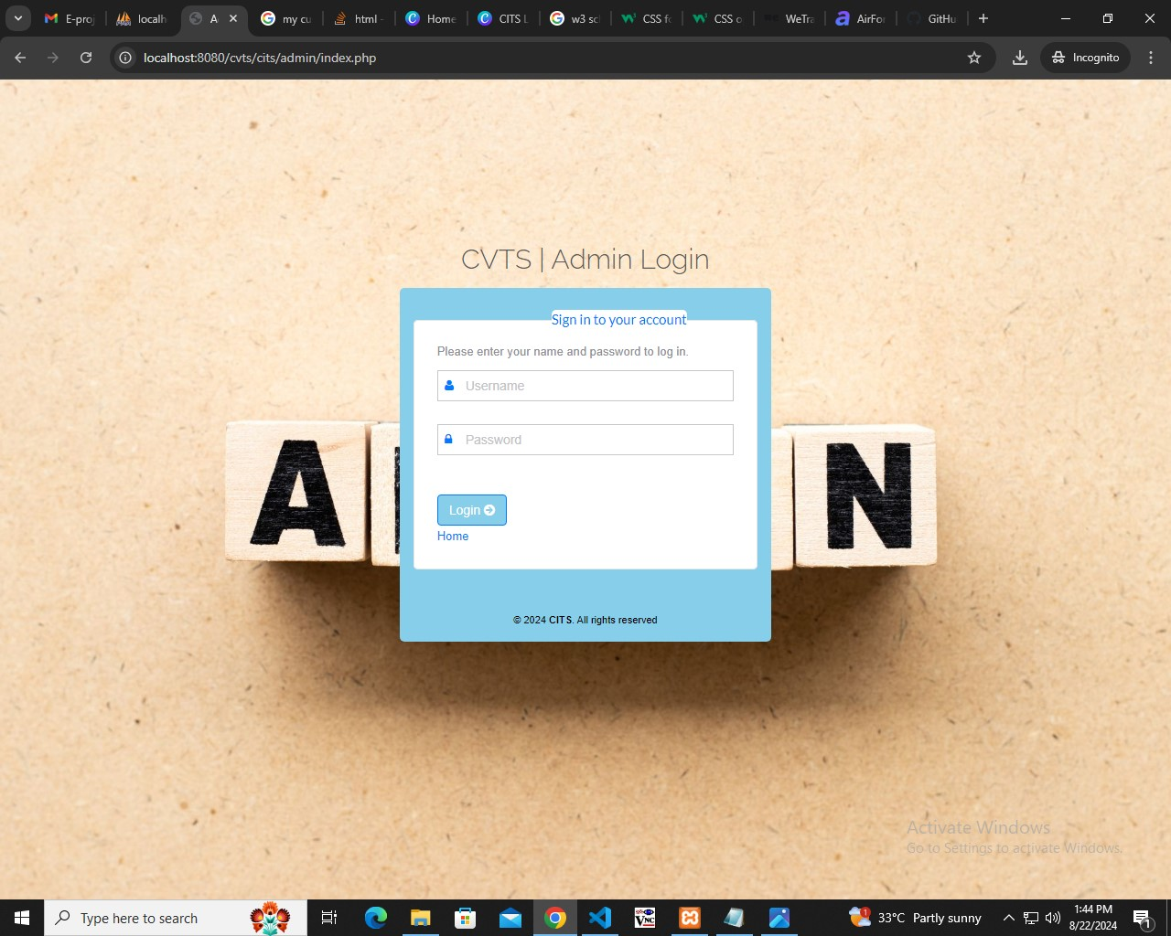

DOCTORS

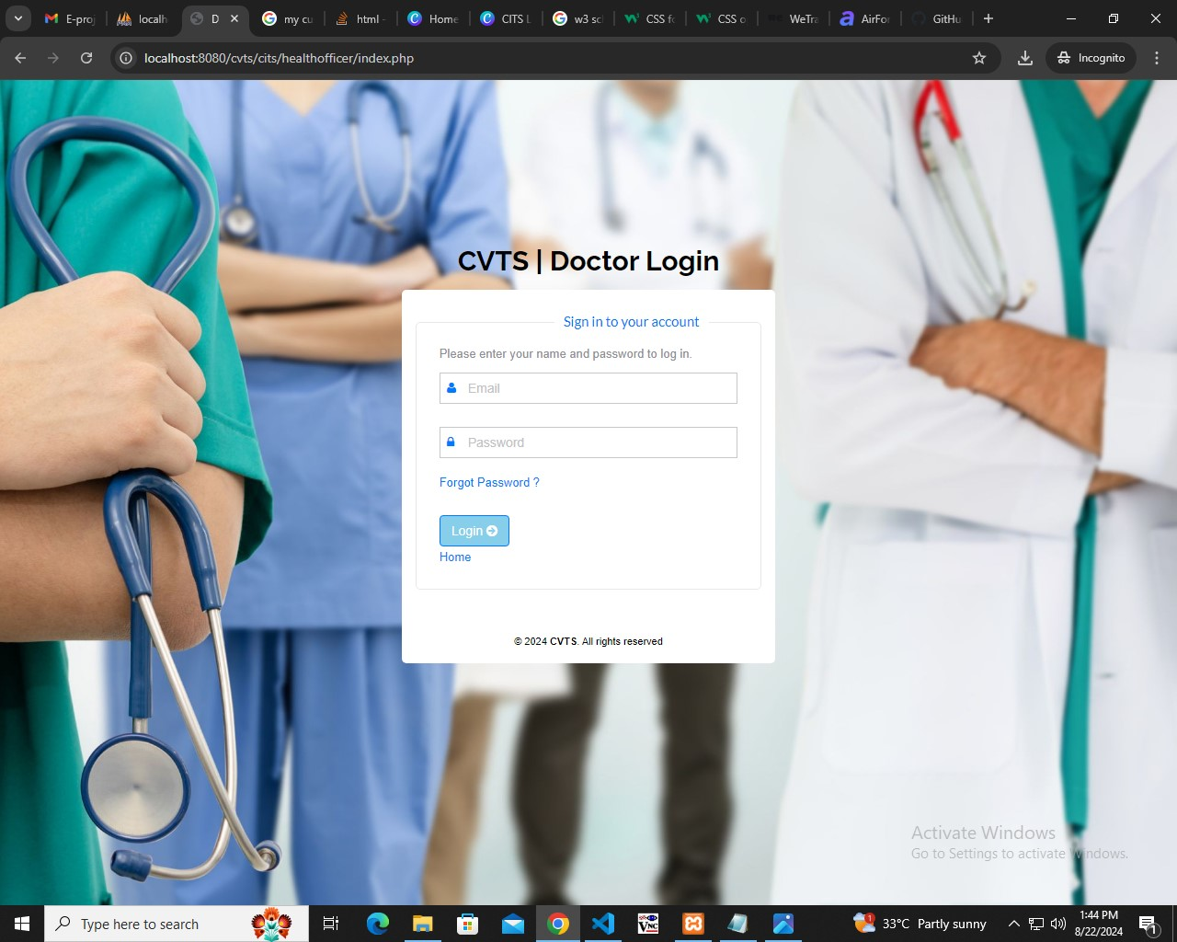

USER LOGIN

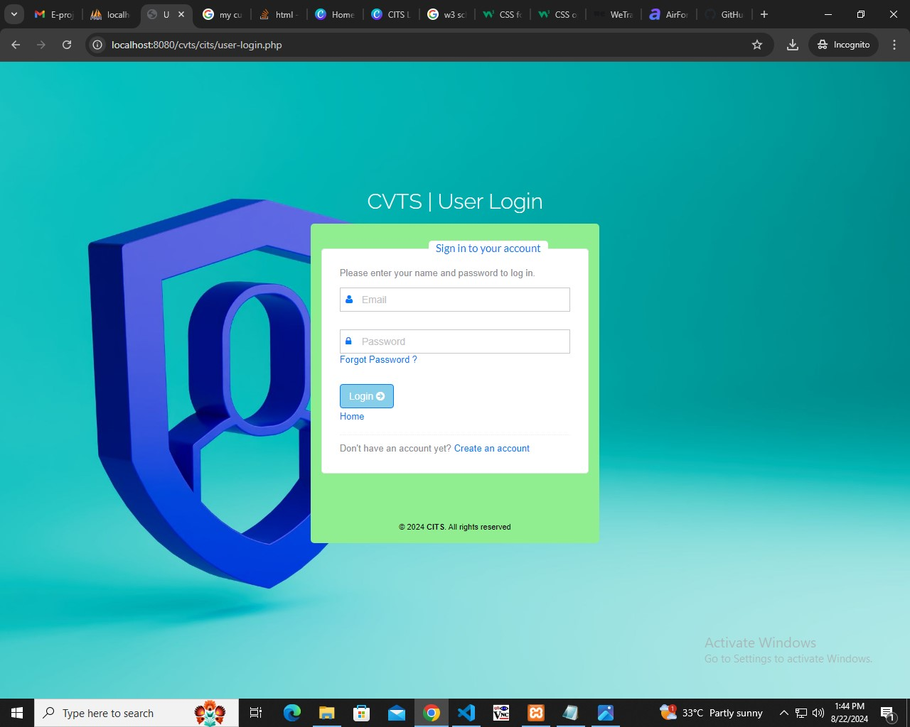

USER DASHBOARD

\

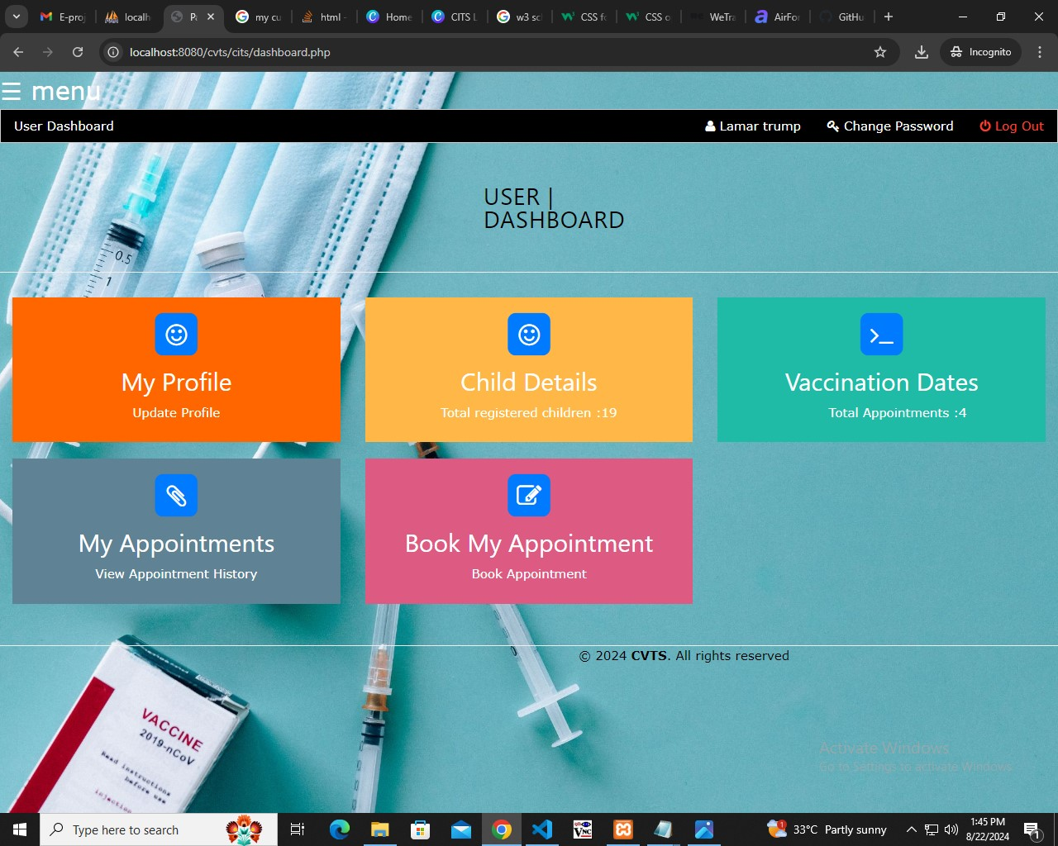

ABOUT US

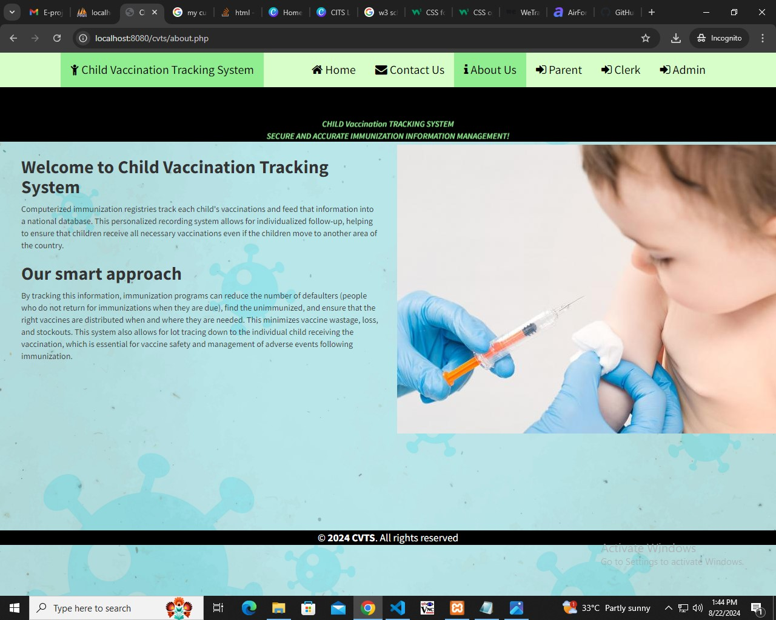

CONTACT US

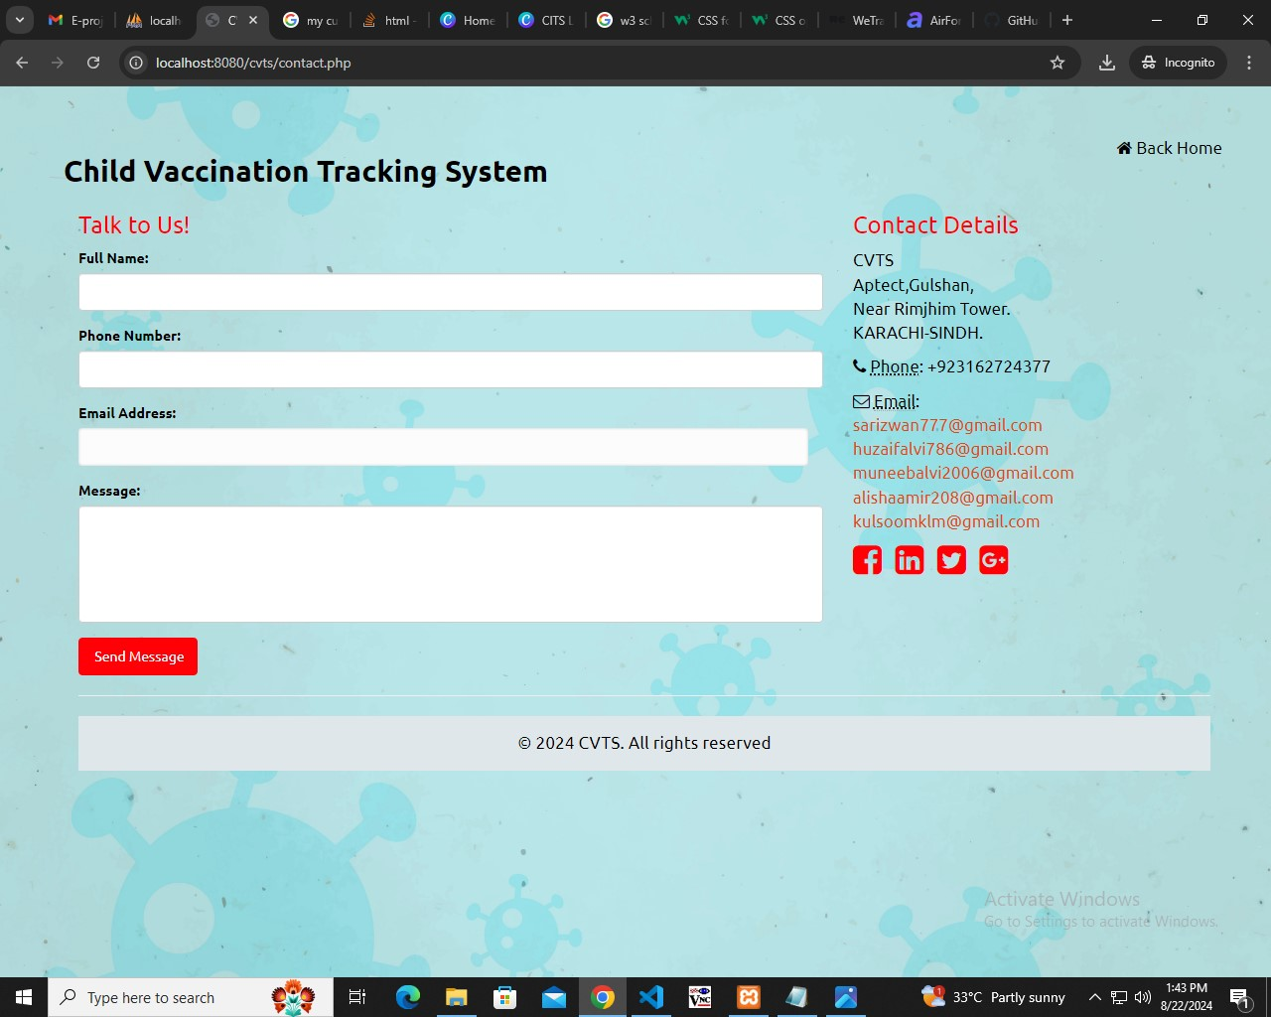

THE END

HOPE YOU LIKE IT!
S

